These are the files that the code returned when I ran it:

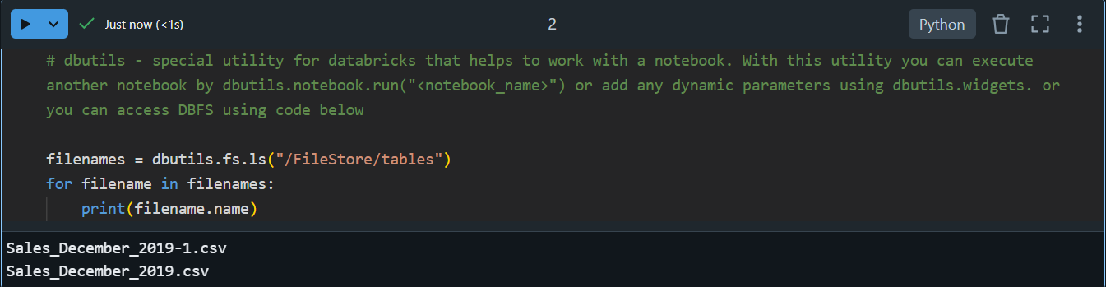

Task 1-Write data from table that you created into the dataframe using PySpark with SQL query. Show data in the dataframe

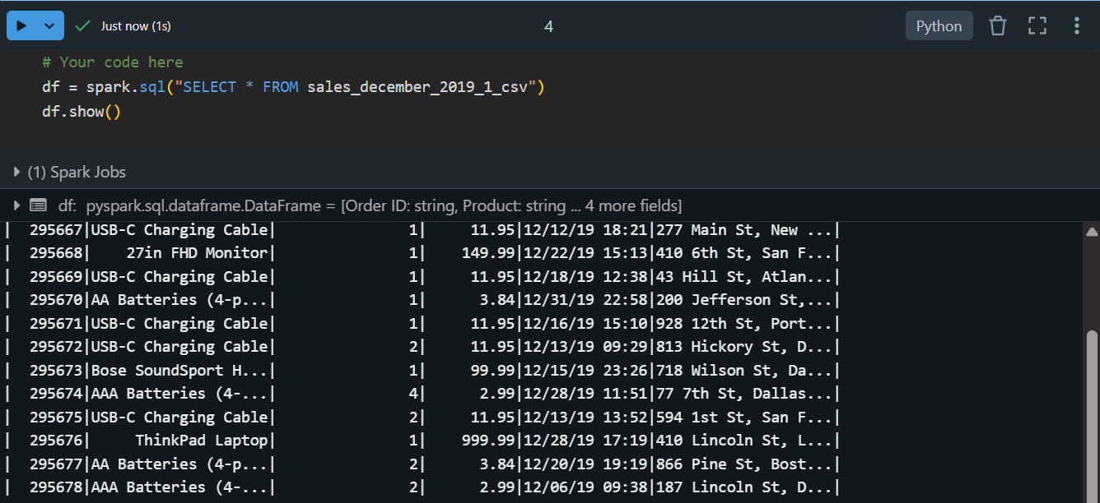

Task 2-Select data where product = "product_name" from dataframe using PySpark

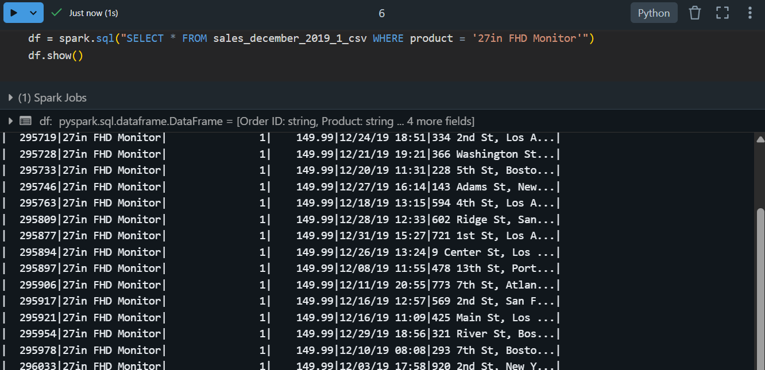

Task 3-Calculate the sales for each product, including the number of products sold

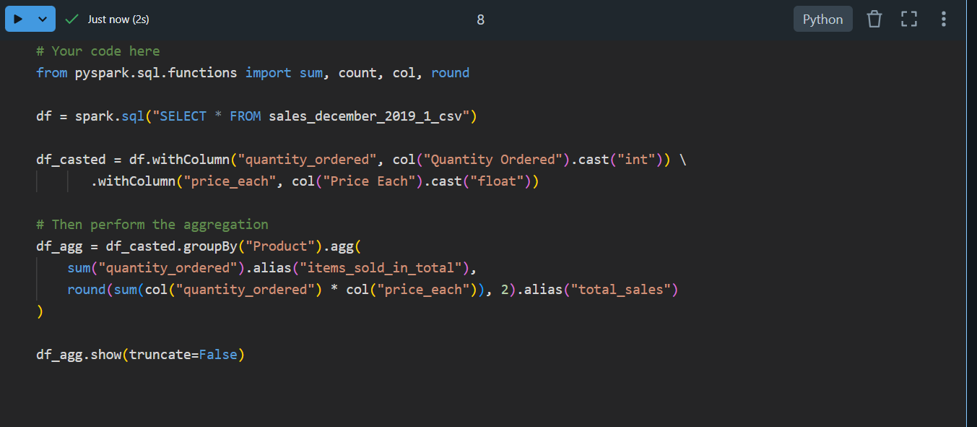

And this is the output of this code:

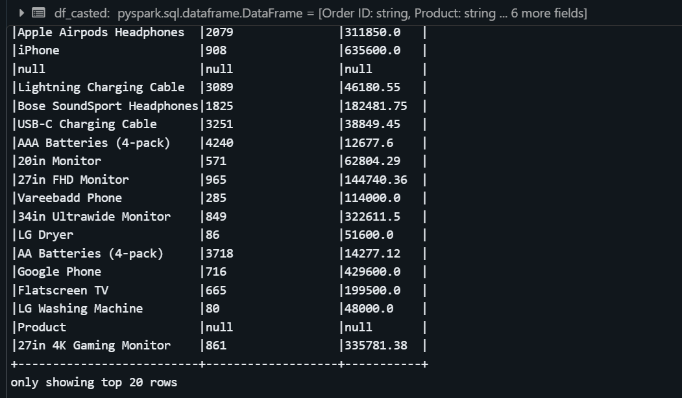

Task 4-Show data profiles output for the new dataframe of table sales_december_2019_csv: row count, min and max value for each column

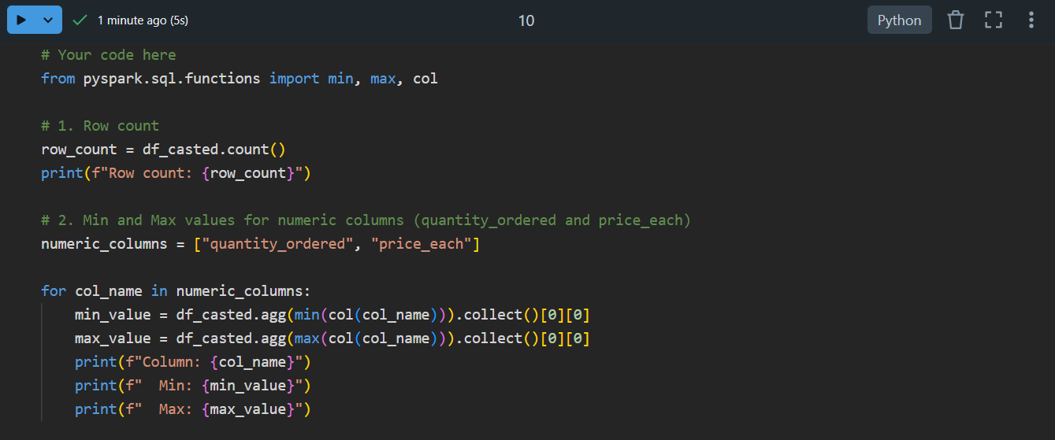

Output is this: 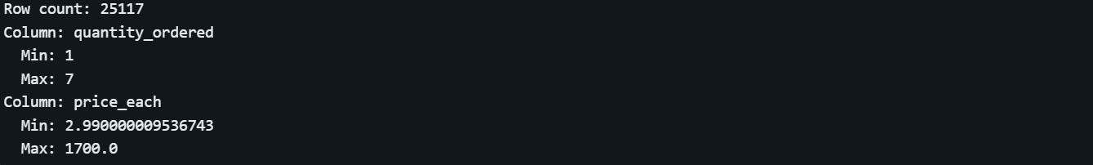

Task 5-Add new column to the dataframe from previous task with any default value that you want

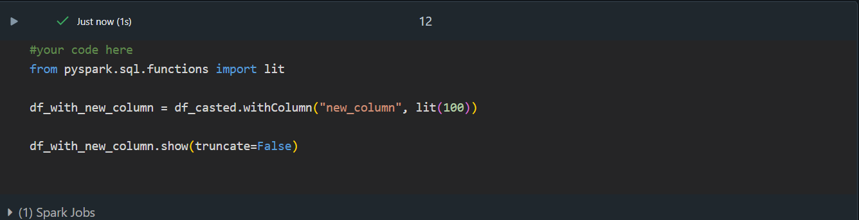

And this is the output:

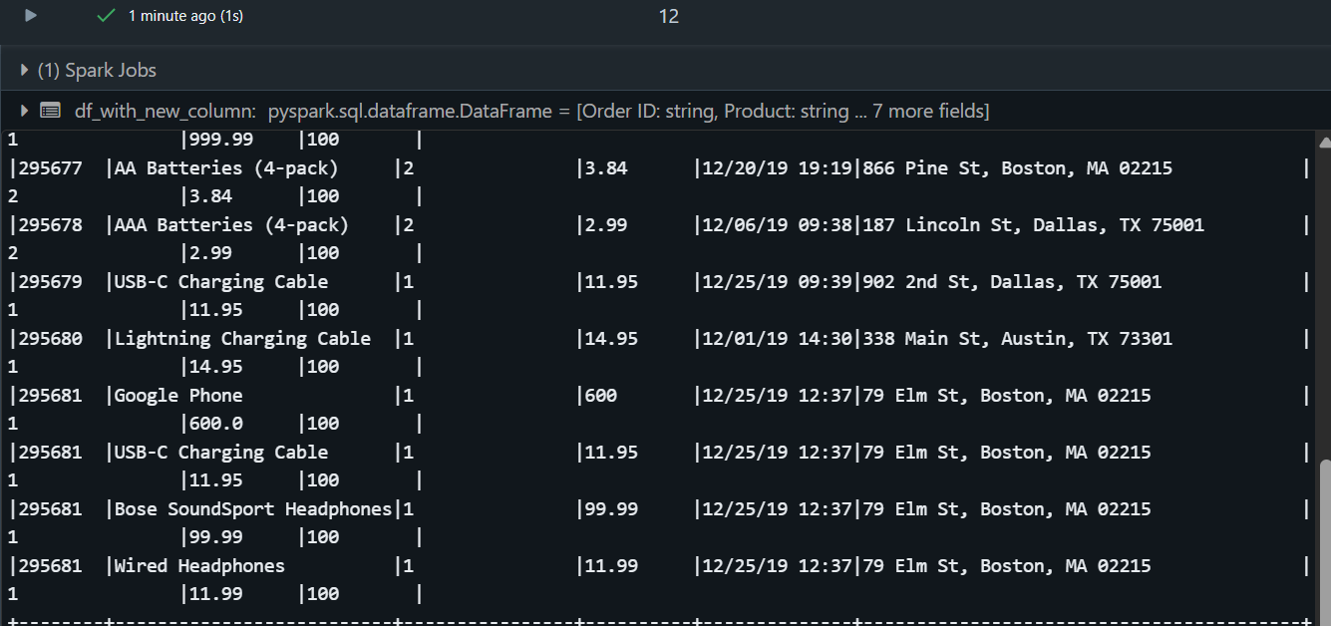

Task 6-Create temporary view from task 4 dataframe using PySpark and perform any select using SQL

Here is the code:

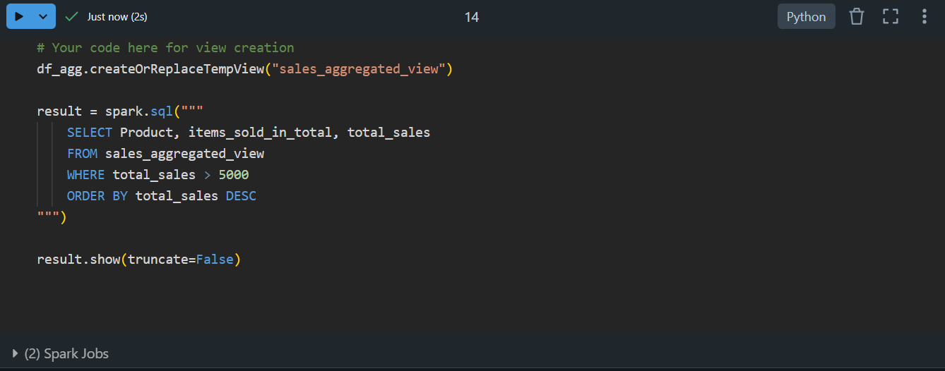

And this is the output:

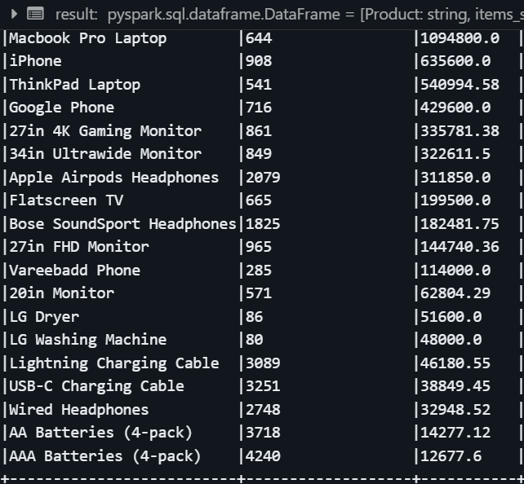

And I rechecked it with sql code also:

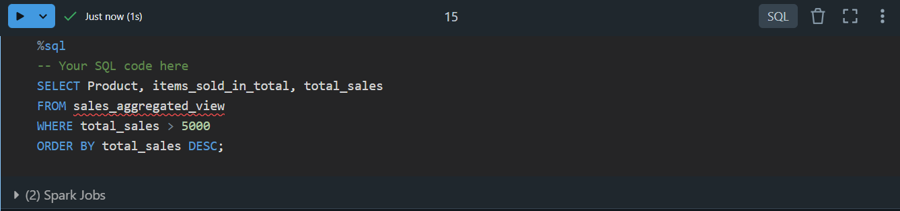

Result:

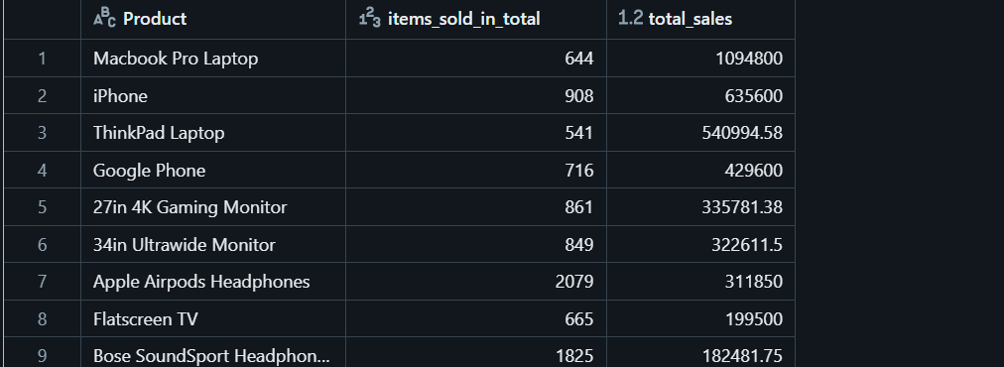

But this is the only small part

Task 7-Export dataframe from task 5 as .parquet file to the DBFS and show that databricks creates folder with .parquet files

Code part:

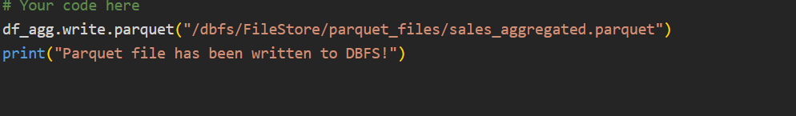

Output:



Task 8-Create table from .parquet files that was created in the previous cell using pure SQL

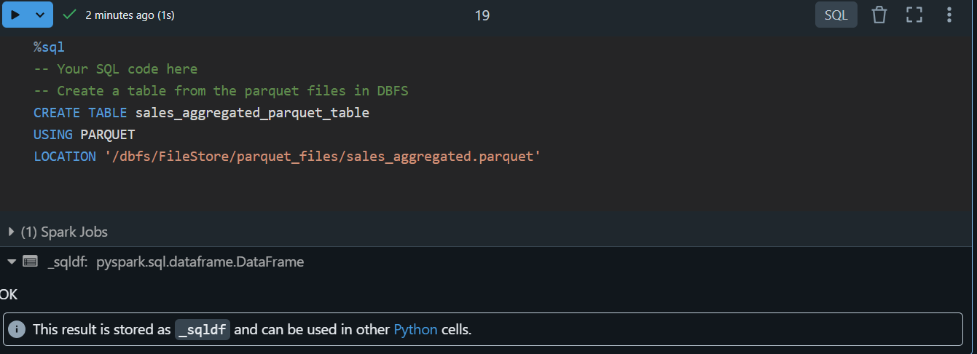

Task 9-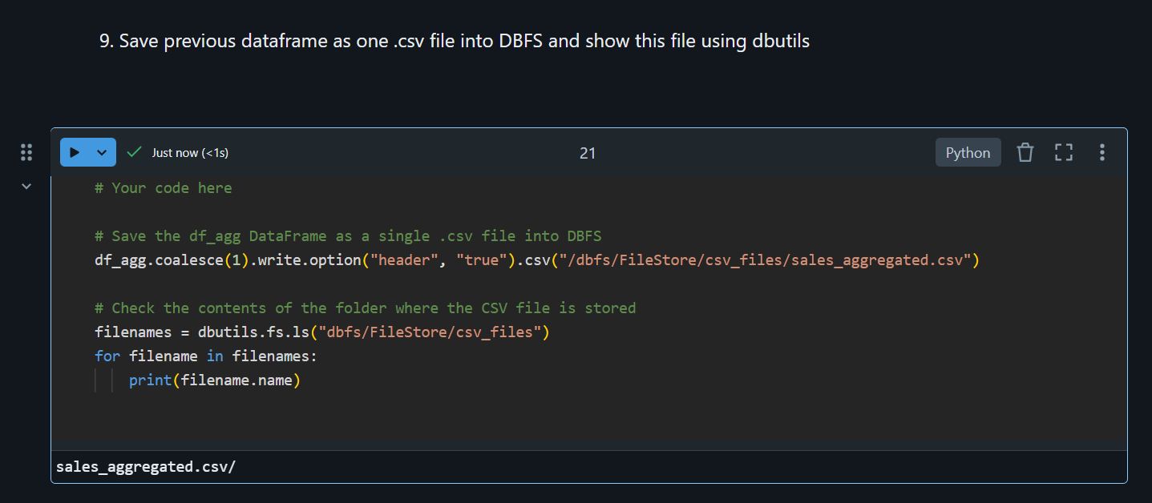

Task 9.1:

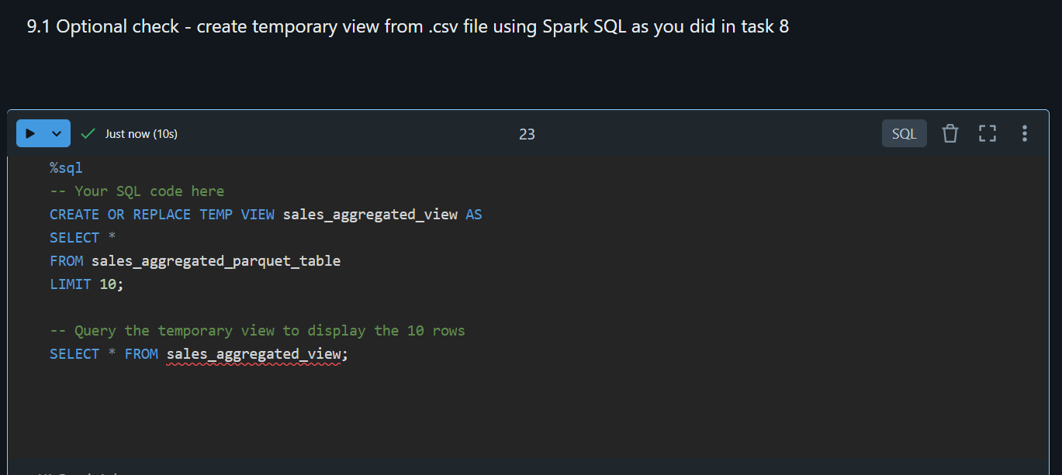

Output:

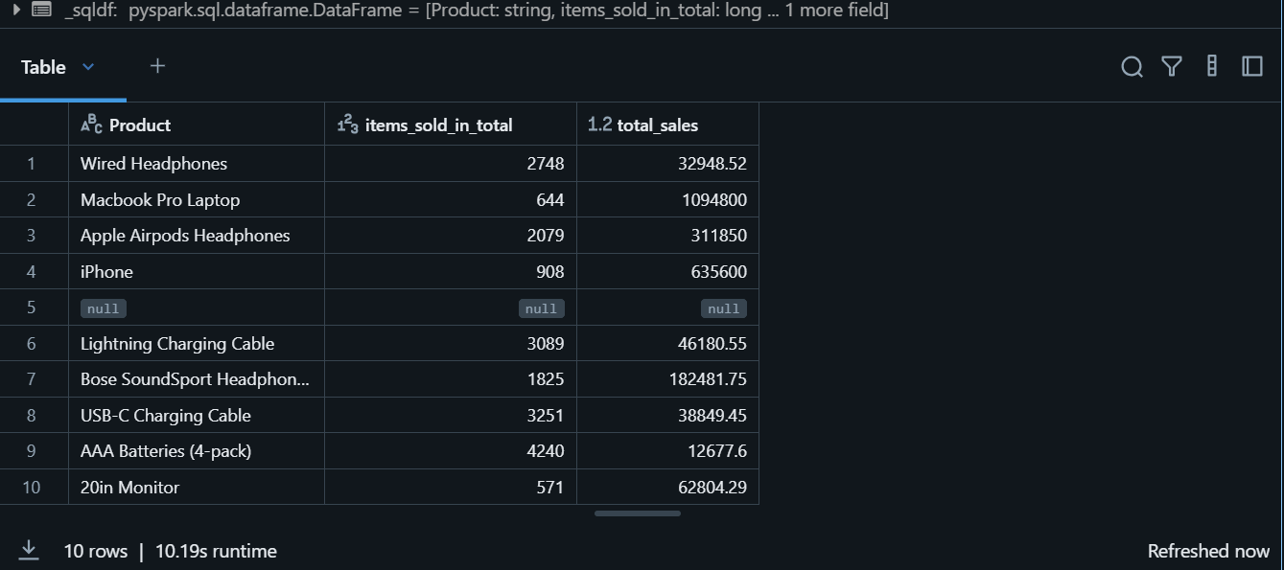

I don’t know if you are able to visit this link but for any case I will upload the link to this directory:

[https://community.cloud.databricks.com/editor/notebooks/1141659624815398?o=4469874836556395#command/1141659624815421](https://community.cloud.databricks.com/editor/notebooks/1141659624815398?o=4469874836556395%23command/1141659624815421)